Chapter 2 p.18

Pre-ransom notifications by industry

Pie chart showing Pre-ransom notifications by industry. It shows approx. one-fourth region is covered by Discrete Manufacturing, and Higher Education, followed by equal divisions of Real Estate, Professional Services, Consumer Goods, Retailers, Primary & Secondary Edu/K-12, IT Services & Business Advisory, Insurance, Gov Ops & Infrastructure, Power & Utilities, Media & Entertainment, Health Provider, Water & Sewage, Automotive & Mobility, Capital Markets, Medical Manufacturing, Automobile, and Telecommunications.

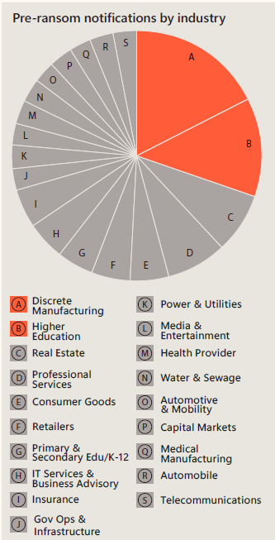

Source: Microsoft Defender Experts notifications